**Lab 9: Experiment using AR**

[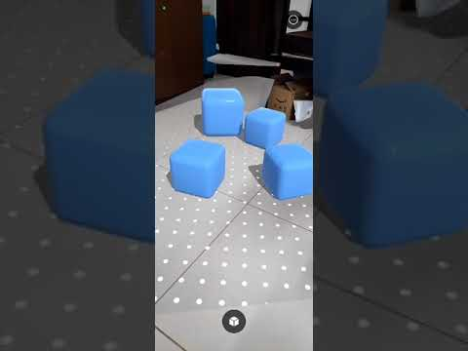](https://youtube.com/shorts/pimLHFTbWRA)

1. Create a new project using AR Mobile template.

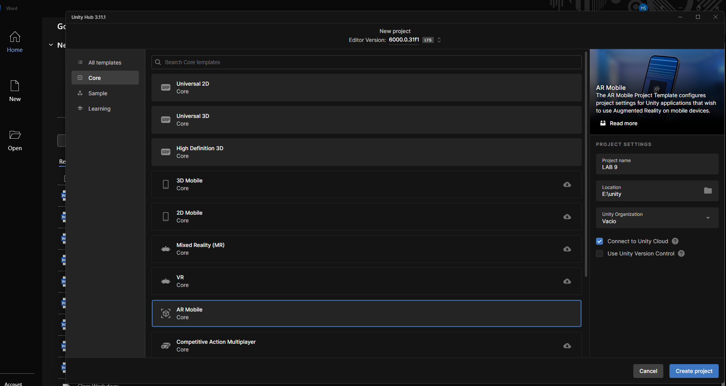

1. Configure Build settings

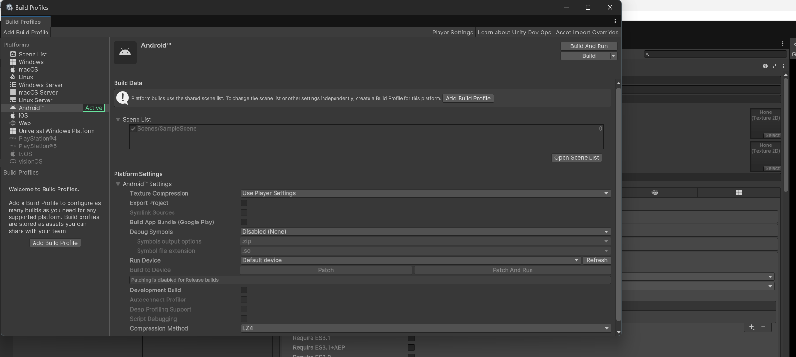

1. Configure Project Settings

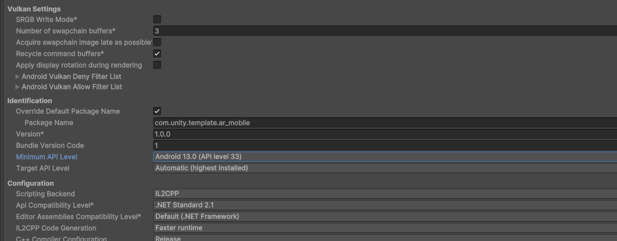

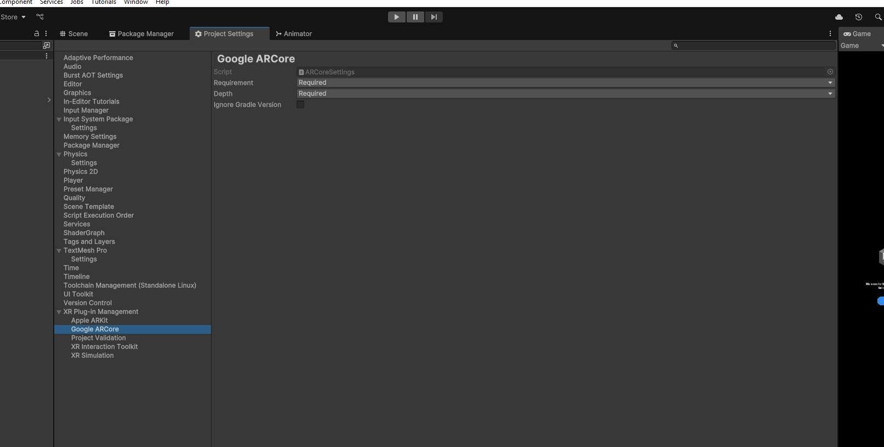

1. Add AR session, XT origin Ar rig to the scene

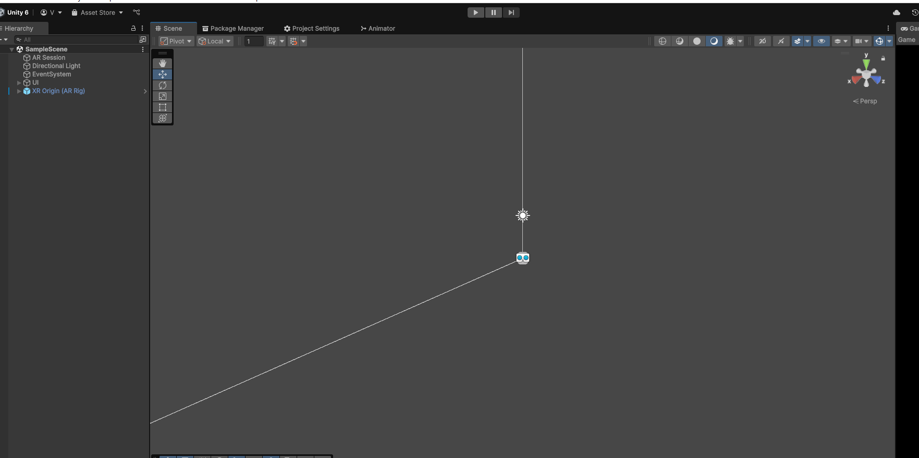

1. Configure the AR session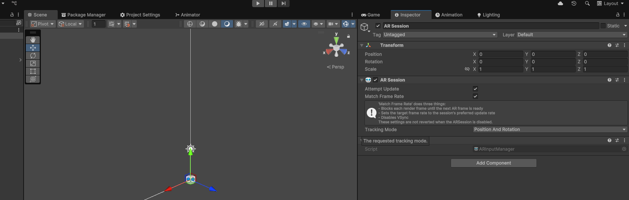
2. Create a Ui and other game logic

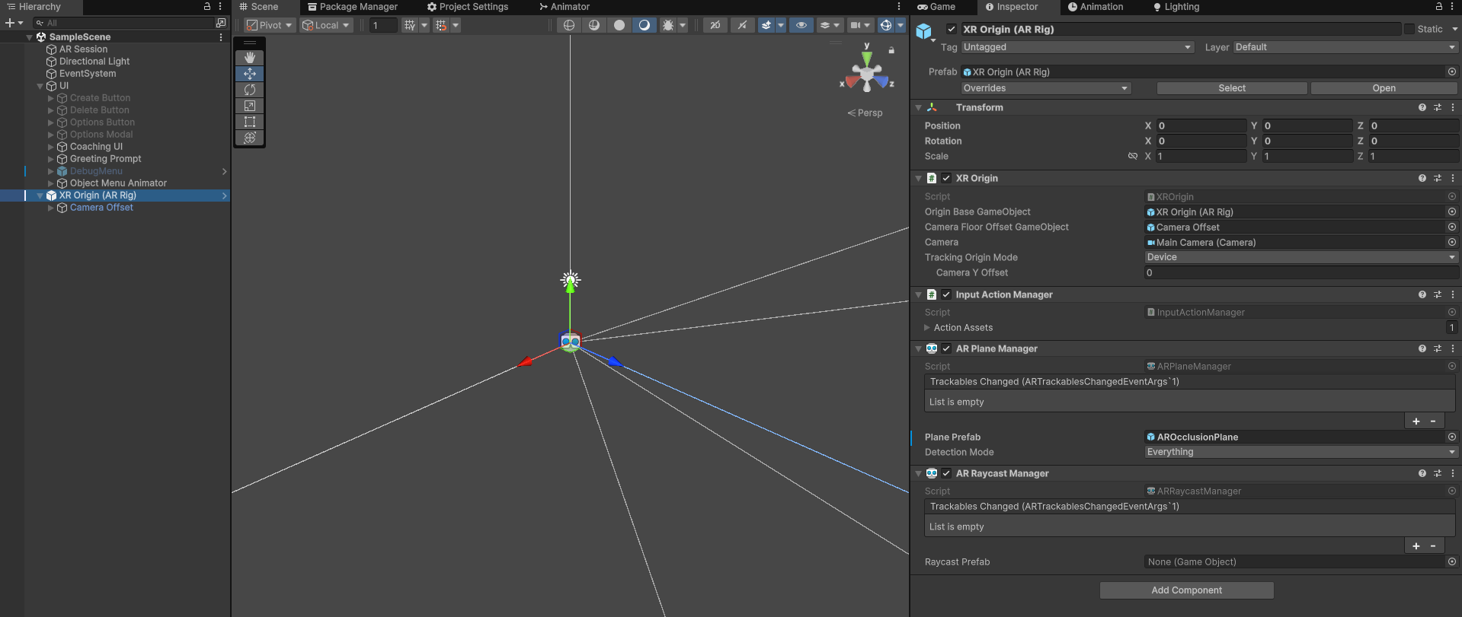

1. Build The Game

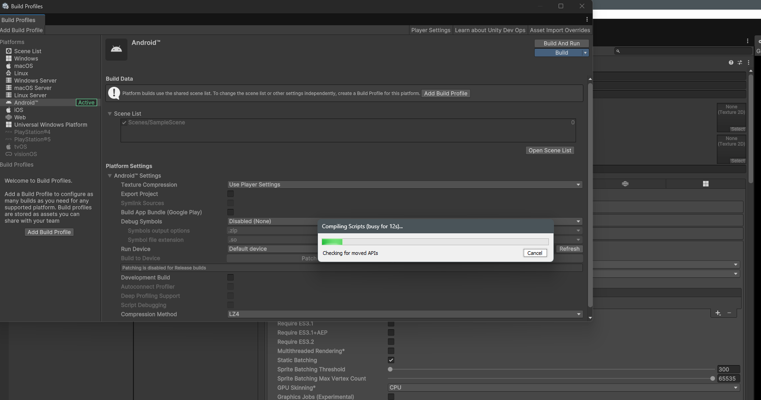

1. Download apk on mobile and run it
2. Play the experience